PyCitySchools

# Overview

There are 15 schools in the sample dataset for the district with 39,170 students and a budget of $24.6 million amongst them. About 75% of students are passing math, 86% passing reading, but only %65 passing both according to standardized test results.

If things were split equivalently each school would have about 2611 students each with a budget of $629.29 per student. If passing is considered 70% or above for all areas and subjects under discretion the district may be passing in math and reading individually but overall, they would be failing.

District and Charter schools make up the types of schools in the area. There are 7 District schools and 8 Charter. All district schools have greater total students than the charter schools.

# Trends

## Top/Bottom Overall Passing

All top five overall passing schools were charter school and had a pass rate of at least 90%. Meanwhile the bottom five schools were all district schools and only had students passing about 53% of the time. The budgets cannot be said that they come into play because the average budget for the passing schools per student is $604 to bottom schools at $646.

While comparing average math and reading scores between these two group, the top five schools are averaging B’s in both categories while the bottom five schools are averaging C’s for math and B’s for reading. The top five schools have more than 93% of their students passing math and more than 95% of students passing reading. The bottom five schools have about 66% of students passing math and 80% of students passing reading.

## Scores by School Spending

When looking at the spending per student compared to the passing rate of both subjects individually and overall, there is a clear trend. The schools with less budget per student are performing better than the schools with a larger budget per student.

## Scores by School Size

Based on the data for this district, small and medium schools perform well in math, reading, and overall. The large schools show a significant decrease in pass rate across all categories.

## Scores by School Type

The data also provides that the charter schools are outperforming the district schools in all categories listed. There is a difference of 6+ points in math, 2+ points in reading, 27% difference passing math, 16% difference passing reading, and 37% difference passing overall.

# No Trends

## Per Student Budget

Between the charter and district schools there is not too much variation of budgets per student. There is less than $100 difference between the school with the largest budget per student at $650 and the school with the smallest budget per student at $578.

## Math Scores by Grade

Looking at the average score by grade for math does not reveal much of a telling trend. Schools stay relative consistent in their scores, within 3%, across all four years. Only a one school shows a consistent and minor trend up for math scores (Figueroa); no schools show a consistent and minor trend down.

## Reading Scores by Grade

Reading scores also stay consistent between grades, within 2% and do not show a trend upward or downward through the grades.

# Appendix

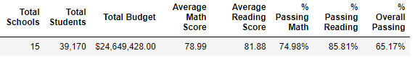

Figure District Summary

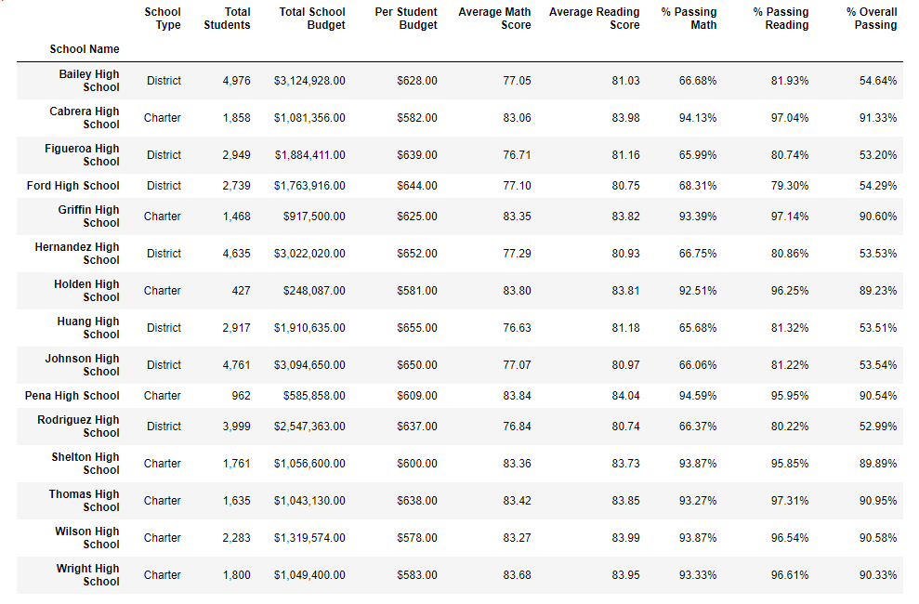

Figure Schools Summary

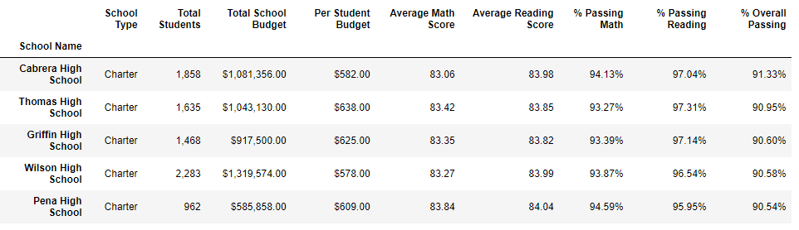

Figure Top Performing Schools (By % Overall Passing)

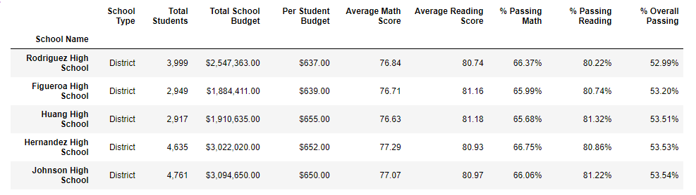

Figure Bottom Performing Schools (By % Overall Passing)

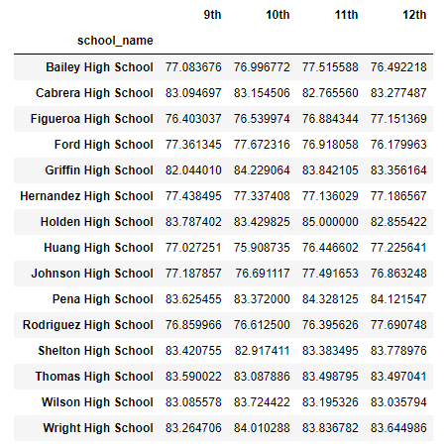

Figure Math Scores by Grade

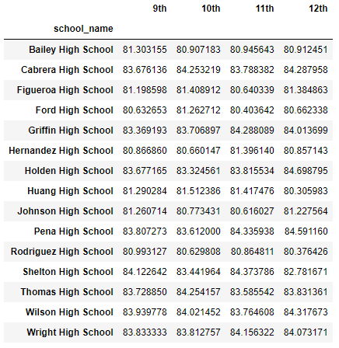

Figure Reading Scores by Grade

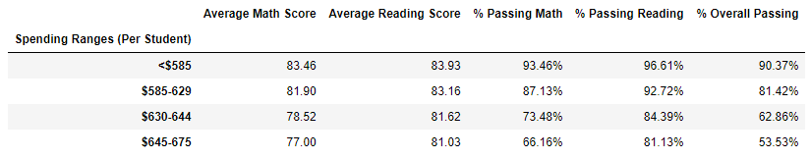

Figure Scores by School Spending

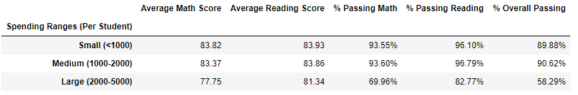

Figure Scores by School Size

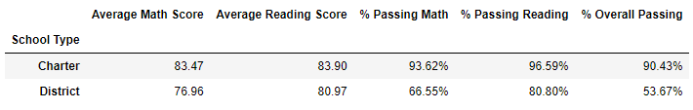

Figure Scores by School Type